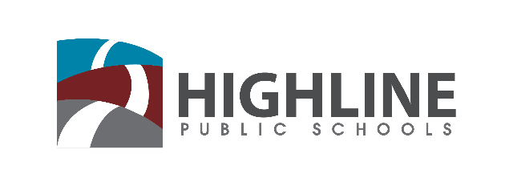

Policy 0010 P4

CULTURALLY RESPONSIVE PRACTICES

Highline Public Schools is focused on embedding culturally responsive practices into our work and ensuring that all staff use these practices in their interactions with students, families, and the community. We will engage our families and community in identifying these practices and educate our staff in how best to use them. To that end, we will:

- Engage our staff, students, families and community members in the development and implementation of culturally appropriate and effective partnerships between home and school.

- Use culturally responsive practices that effectively engage individual students, staff and community.

- Intentionally seek out and include the student and family perspective, particularly racial perspectives, in the development and implementation of culturally responsive teaching and learning practices and curriculum.

- Leverage the work of Social Emotional Learning to provide culturally responsive spaces for learning and working.

- Support home language learning through enrichment programs, heritage language classes and community learning opportunities.

- Partner with families to develop and monitor a step-by-step plan for each student that will enable successful transitions between grade levels and schools.

Accountability
Prior to each Equity Symposium the Superintendent will issue a report updating each area of work, including progress made and areas for improvement, as well as areas that will be changing for the upcoming year. The report should include both qualitative and quantitative data and may result in recommendations to change policies, procedures, or practices throughout the district.

