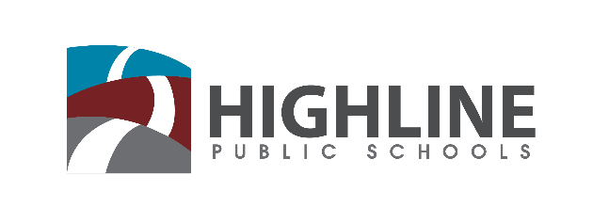

Policy 0010 P5

INSTRUCTION ON RACE AND IDENTITY

Highline Public Schools is committed to working directly with students on topics of race and identity. This includes engaging with families to identify tools and metrics that are culturally relevant to teach this content. To do this we will:

- We use the Social Justice Standards created by Teaching Tolerance in this work. These standards provide a clear and well-designed trajectory to engage students in learning about race and identity, among other critical components. The standards are broad enough to respond to evolving political and social situations, yet specific enough to support well-sequenced instruction. This strong set of standards aligns with Highline’s approach to standards-based instruction by providing clarity to students and support to guide teachers and other staff who regularly interact with students.

- Develop a phase-in implementation plan for teaching this content that uses a phase-in structure, with all schools at full implementation by fall 2023.

- Develop system-wide frameworks for each grade level, aligned with existing instruction, to guide a minimum of 10 hours of direct instruction on this content at each grade level.

- Identify a community advisory council to convene regularly to provide guidance and consultation for professional learning, instructional design, and implementation.

Accountability
Prior to each Equity Symposium the Superintendent will issue a report updating each area of work, including progress made and areas for improvement, as well as areas that will be changing for the upcoming year. The report should include both qualitative and quantitative data and may result in recommendations to change policies, procedures, or practices throughout the district.

