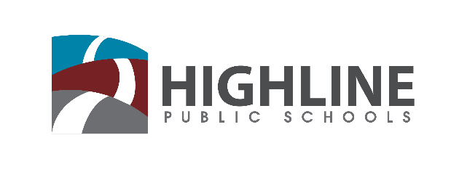

Policy 0010 P2

INSTITUTIONAL PRACTICES

As an institution, Highline Public Schools is committed to identifying and eliminating practices that result in inequity, including examining our practices to eliminate both institutional bias and institutional racism. When making decisions that will impact our ability to deliver on this commitment we will use an equity lens to interrogate the question. The Equity Lens identifies five questions that we use in Highline to ensure that our decisions result in equity.

Such decisions include, but are not limited to, staffing; budgeting; initiating, developing, and ending programs or procedures/processes; allocating resources and opportunities; and purchase or implementation of instructional materials. People who believe the Equity Lens has been misused, whether through poor application or failure to apply, are encouraged to bring their concerns to their supervisor, or, if the allegation is that the supervisor misused the Equity Lens, to the District’s Ombusdman.

In addition to the Equity Lens, we will:

- Implement an affirmative strategy to recruit, employ, support, retain, and continuously develop a workforce of racially and culturally competent administrative, instructional, and support staff for recruitment and retention that increases the diversity and inclusiveness of the Highline work environment and reflects the Highline Promise.

- Distribute Highline resources in a way that considers equity in a performance-based budgeting philosophy to eliminate or significantly reduce systemic, measurable inequities in achievement.

- Continuously and comprehensively review disaggregated district-, school-, and student-level data to identify areas of disproportionality and identify strategies to eliminate achievement gaps.

- Assure that all students have access to the same rigorous, standards-based materials while ensuring the creative use of supplemental materials that engage our community of diverse learners.

- Incorporate student voice as a critical part of decision-making.

- Implement and monitor culturally-responsive and anti-racist practices throughout the district and in each school.

Highline Public School Equity Lens
Objective: By using an Equity Lens Highline Public Schools aims to reduce inequities within the institution, including disproportionality in student outcomes. This Lens is intended to help implement the vision outlined in the District’s equity policy (0010) and the strategic plan, which is our equity plan. This Lens will also develop a common vocabulary and protocol for developing and evaluating policies, programs, practices, and decisions to result in more equitable outcomes.
Process: For any policy, program, practice or decision that is being contemplated or evaluated, consider the following questions:

- Who are the groups affected by this policy, program, practice or decision? What are the potential impacts on these groups?

- Does this policy, program, practice or decision have unintended consequences, such as ignoring or worsening existing disparities?

- How have we intentionally involved stakeholders who are also members of the communities impacted by this policy, program, practice or decision? Can the stakeholders validate your assessments in questions 1 and 2?

- What are the barriers to a more equitable implementation of your policy, program, practice or decision? (Consider mandates, politics, emotions, finances, or programs.)

- How will you mitigate any negative impacts and address any barriers that you have identified?

Accountability
Prior to each Equity Symposium the Superintendent will issue a report updating each area of work, including progress made and areas for improvement, as well as areas that will be changing for the upcoming year. The report should include both qualitative and quantitative data and may result in recommendations to change policies, procedures, or practices throughout the district.

